Call for applications: Community Engagement for Pride in Place (Low Hill)

Overview
The Communities Team at the City of Wolverhampton Council has been commissioned by the Pride in Place Low Hill initiative to conduct an extensive survey to gather the insights of local people, especially those whose voices are not usually heard or are ignored. These are people who probably are not currently a part of community networks.
In order to achieve this, the City of Wolverhampton Council is inviting applications from voluntary and community sector organisations to deliver targeted engagement activities in Low Hill. We are aiming to work with up to 10 organisations.
This work will inform the development of a community-led Regeneration and Investment Plan, due for submission in November 2026.
About Pride in Place
The Pride in Place programme, delivered through the Government's Plan for Neighbourhoods initiative is supporting designated neighbourhoods across the UK to work with residents, businesses and local stakeholders to develop long-term regeneration and investment plans.
Plans must be:
- Co-designed with residents and stakeholders
- Underpinned by robust engagement evidence
- Aligned with three strategic objectives:
1. Creating thriving places
2. Building stronger communities
3. Empowering people to take back control
Purpose of the work
To engage people who live, work, run businesses in, or regularly visit Low Hill through face-to-face engagement activity and survey collection.
Scope of the work
Commissioned organisations will:
- Host consultation events in accessible community locations (e.g. pop-ups, door knocking, venue-based events including outdoor locations)
- Facilitate completion of paper and/or digital surveys (preferred)
- Target diverse demographics and neighbourhoods, including children and young people, older people, ethnic minority groups, people with disabilities and different faith backgrounds.
- Work alongside the Council's Communities Team to avoid duplication of activity and help reach communities that may otherwise be underrepresented.
We are not looking for sessions to take place in schools. School engagement will be achieved by a different methodology
Area of benefit
Organisations will be required to deliver engagement activities across the area shown within the red boundary on the map below. Activities may also take place in community venues, including outdoor spaces, located just outside the area where this supports engagement with local residents.
Please consider the defined area below when developing your proposal. If your application is successful, we will work with you to agree and approve any engagement locations.
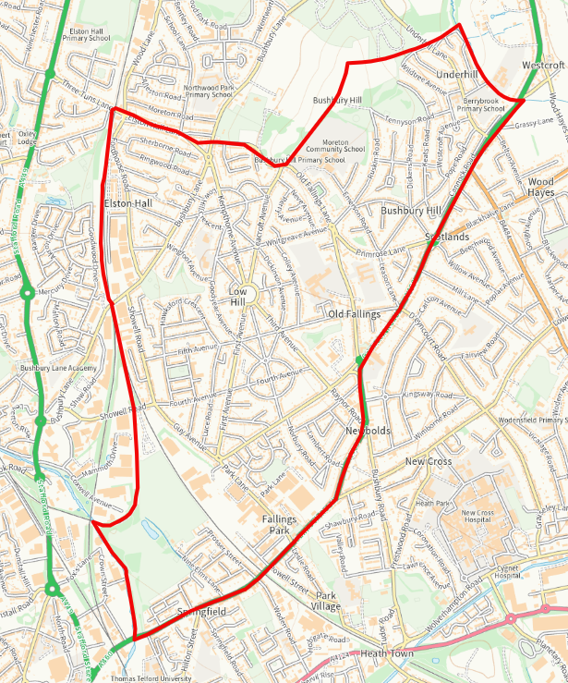
Organisations will be expected to undertake proactive outreach activity within the community. This may include engagement through existing community networks and relationships where appropriate, but funded activity should be focused on reaching residents, businesses and other stakeholders within the Low Hill area through direct engagement approaches.
This may include:
- On-street engagement and survey collection in high footfall areas
- Outreach in collaboration with voluntary and community sector organisations
- Direct engagement with local businesses and employers
- Activities delivered through faith organisations and community faith settings
- Any other relevant community networks or spaces that support reaching a diverse range of people

Expected Outputs

- Minimum of 50 completed surveys per full day of activity
- Basic demographic data (age group, gender, postcode)
- Daily summary of engagement activity (location, number approached, feedback)
Time Commitment
Up to 7 days of activity between 17 August and 25 September. Days can be non-consecutive and scheduled in coordination with the Communities Team.

Day rate

A flat rate of £300 per full day (£150 per half day) will be paid where surveys are submitted electronically through Citizen Space.
A flat rate of £250 per full day (£125 per half day) will be paid where surveys are completed on paper and require manual processing by the Council.
This reflects:
- Local benchmarks for engagement work
- Costs for staffing, travel, materials, and venue hire
- Expected output of approximately 50 responses per day (equivalent to around £6 per completed digital response)
- The additional administrative costs to the Council of inputting data from paper responses
Support provided
- Consultation materials – surveys and promotional letters for residents
- Access to Citizen Space Consultation Hub
- Briefing session on objectives and tools
- Promotional support via Council communications
Reporting requirements
- Electronic surveys submitted via Citizen Space (preferred)
- Paper surveys must be submitted alongside a record of the number collected and the dates of engagement activity.
All paper surveys must be returned either scanned or in hard copy by 25 September 2026.
Selection Criteria
Applications will be assessed against:
- Demonstrable presence in, or established relationships with, communities within the Low Hill area.
- Ability to reach communities and groups that may otherwise be under-represented in the consultation.
- Experience of community engagement, consultation or outreach activity.
- Capacity to deliver the required outputs within the project timescales.
- The extent to which the proposal complements the overall engagement programme and contributes to achieving a broad geographic and demographic reach.
Payment
Payment will be made on receipt of a valid invoice and satisfactory evidence that the agreed outputs have been delivered.
How to apply
Up to 10 organisations will be commissioned through this process.
If more than 10 eligible applications are received, applications will be assessed against the published selection criteria. The Council may also take account of the need to achieve a balanced range of organisations, communities and geographic coverage across the Low Hill area when making final commissioning decisions.
Please complete and submit the Expression of Interest form, including:
- Overview of your organisation and relevant experience
- Proposed approach to delivering the engagement
- Target neighbourhoods or demographics
- Availability during the fieldwork period
- Contact details
Submit your Expression of Interest to:
LoveYourCommunity@wolverhampton.gov.uk
Deadline for expressions of interest: No later than midnight on Wednesday 12th August 2026

